# Lab 1:

**Introduction to the Microcontroller Development System**  
 **Name:** ____REZA SHISHEIE__________________________**ID**__2708062________

Due dates:  
  
MW Section – Mon, Feb 5

TTh Section – Tue, Feb 6

Give brief answers to the following questions. You can use this document to insert your answers. They can be typed or handwritten, but they must be neatly written. Only hardcopies will be accepted, no emails. The assignments must be submitted on or before the due date before the beginning of class. The score for late labs will be reduced by 10% if the lab is submitted after class on the due date. The score will be reduced by 20% if submitted by the beginning of the next class day after the due date. After that, the score will be zero.

Calculations should be carried out to four significant digits, and any formulas used should be shown, even if the formula is trivial. This will maximize your potential for partial credit.

1. (1 pt) Search for the Wikipedia article on “Disassembler”. What is the definition of a disassembler?  
     
   **Ans.**   
   A disassembler is a computer program that translates machine language into assembly language—the inverse operation to that of an assembler
2. (1 pt) In the lab01.asm source code, what is the first assembly directive that is used, and what is its function? Which option is used with the directive, and what is its function?  
     
   **Ans.**

The 'list' directive instructs the assembler to create a list file which contains detailed disassembly information. The 'p' option of the 'list' directive configures the assembler for the correct processor type. Putting the directive in the source code insures that the assembler is configured for the correct processor in other environments.

1. (1 pt) According to the lab01.asm source code, the __config directive sets the configuration word. What is the address of the configuration word in program memory? Express the address in hex and in decimal. When can this memory location be accessed?  
     
   **Ans.**

The '__config' directive (double underscore) instructs the assembler to set certain processor configuration bits in the configuration register located at 2007h (8199d) in program memory.

The configuration bits are used to select various device configurations such as enabling/disabling the watchdog timer.

1. (1 pt) How many bits does the configuration word have? What is the default contents of the configuration word in hex and binary. (Express all binary answers in groups of 4-bit nibbles for ease of reading, for example, 0x9C = 1001 1100).  
     
   **Ans.**

The configuration code has 14 bits.

The erased (unprogrammed) value of the configuration word is 3FFFh. The binary value if the default configuration word is 11 1111 1111 1111

1. (1 pt) What is the mnemonic for bit-6 in the configuration word? What is its meaning?  
     
   **Ans.**

Starting from bit-0 BODEN is at bit-6  
BODEN: Brown-out Reset Enable bit

1 = BOR enabled

0 = BOR disabled

The configuration bit, BODEN, can enable or disable the Brown-out Reset circuit. If VDD falls below VBOR (parameter D005, about 4V) for longer than TBOR (parameter #35, about 100μS), the brown-out situation will reset the device. If VDD falls below VBOR for less than TBOR, a RESET may not occur.

1. (1 pt) Of the following, check off the ones that are case-sensitive?  
     
   □ Directives  
   □ Instructions  
   X Labels  
   X Variables  
   X Special Function Registers
2. (1 pt) Explain how the decfsz instruction is works in lab01.   
     
   **Ans.**

The 'decfsz' instruction is used for creating loops in MPASM.

“decfsz f, d” means to decrement the contents of register 'f'. If the decremented result is 0, skip the next instruction. Otherwise, execute the next instruction. If d = 0, put the decremented result in the working register W, otherwise, if d = 1, put the result in the 'f' register.

As an example: “decfsz Count, 0” means: Decrement the contents of the register 'Count'. If the result is zero, skip the next instruction. Put the decremented result in the working register W, and leave the contents of 'Count' unchanged.

1. (1 pt) Build (assemble, compile) the source code in lab01.asm. What is the address in data memory of the user-defined variable CountOuter? Give your answer in both hex and decimal.  
     
   **Ans.**

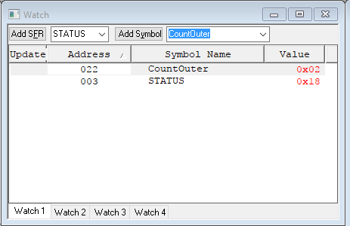

Address: 022h - 34d – 100010b

1. (1 pt) How many instructions does the 16F877 microcontroller have? What are the three categories into which the instructions are divided?  
     
   **Ans.**16F877 microcontroller has 35 instructions

The instruction set is grouped into three basic categories:

* Byte-oriented operations
* Bit-oriented operations
* Literal and control operations

1. (1 pt) According to the MPASM Assembler User Guide, what are the three different ways the decimal number 248 can be represented in assembly code?  
     
   **Ans.**

D’248’

d’248’

.248

1. (1 pt) According to the MPASM Assembler User Guide, how is the EQU directive commonly used in assembly programming?  
     
   **Ans.**

equ is commonly used to assign a variable name to an address location in RAM.

For example: four equ 4 🡪 assigned the numeric value of 4 to label four

1. (1 pt) Download the P16F877_inc_copy.zip file from the Resources folder on the course website. You can open it in the MPLAB editor for color-coded text. Do not alter the original P16F877.inc file that is in the MPLAB installation folder on your machine, because it is used by the assembler. Find the entry for EEADR. What is the hex number associated with EEADR. What is the decimal equivalent of the hex number?   
     
   **Ans.**

EEADR EQU H'010D'

Decimal: 269

1. (1 pt) For the above problem, what does the hex number represent? (Hint: See the register file map in the data sheet.)  
     
   **Ans.**   
   EEPROM Address Register Low Byte
2. (2 pts) In the P16F877.inc file, what are the listings for the symbols F and W ? What is the difference between the results of the following instructions:  
     
   addwf PORTA, F   
   addwf PORTA, W?  
     
   **Ans.**W EQU H'0000'

F EQU H'0001'

addwf f,d

addwf takes the value of PORTA (f) and adds it with the value of W register, and if F(d) is 1 the result is stored in f which is PORTA in this case.

addwf takes the value of PORTA (f) and adds it with the value of W register, and if W(d) is 0 the result is stored in W register.

1. (1 pt) Suppose <RP1:RP0> = 01. What is the assembly instruction for the opcode  
   00 1000 0001 1001?  
     
   **Ans.**

<RP1:RP0> = 01 🡪 Bank1

00 1000 = MOVEF f,d

00 1000 dfff ffff

d=0

fff ffff = 001 1001 = 19h = 25d = SPBRG

MOVEF SPBRG,0

1. (1 pt) Write the opcode for the instruction bsf STATUS 6.  
     
   **Ans.**

bsf Architecture: 01 01bb bfff ffff

* bbb=6=110
* fff ffff= 03h=000 0011

RESULT: 01 0111 0000 0011

1. (1 pt) Explicitly show the steps used to convert 0x010D to decimal without a calculator. (Hint: Expand 0x010D in powers of 16.) You need to know this because calculators are not permitted on exams. Show the steps required to convert b’10010110’ to decimal.  
     
   **Ans. $$13*{16}^{0}+0*{16}^{1}+1*{16}^{2}+0^{{16}^{3}}=269$$**   
   1*128+0*64+0*32+1*16+0*8+1*4+1*2+0*1=150
2. (1 pt) Build your Lab01 project and program the PIC. Configure your windows so you can see both the **Program Memory** window and the **lab01.asm Editor** window.   
   Set a breakpoint at the last **instruction** in the program, and run the program until you reach the breakpoint. What is the address of the last instruction? To what address does the program counter (PC) jump when this instruction is executed?   
     
   **Ans.**

The address of the instruction is at 001C

It jumps to address 0x16

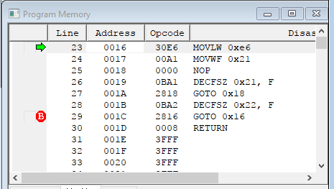

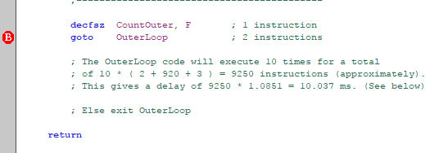

1. (1 pt) Select **View → Watch** to open the Watch window. Select STATUS from the SFR selection box at the top of the window. Click **Add SFR** to add it to the Watch window list. Select WREG from the SFR selection box and click **Add SFR** to add it to the Watch window list. Right-click the header row and select Binary and Decimal. Reset the program and step into the program until the WREG register changes (turns red). What value does WREG change to? Which instruction caused the change ?  
     
   **Ans.**

WREG changes to 50 which is the value taken at movlw

Instruction movlw d'50' caused it turn red

|  |  |
| --- | --- |
|  |  |
| Initial condition | Once it turns red |

1. (15 pts) Demonstrate your functioning lab01 circuit and software to the instructor or TA. Then demonstrate to the instructor or TA that you know how to: (1) set a breakpoint; (2) run the program to the breakpoint; (3) step through the code; and (4) observe variables changing in the watch window.

Done

**Student Name (Print):**______________________________________________________  
  
**Instructor or TA signature and date**: ______________________________________